Glossary of Terms

**ACC: Adaptive Cruise Control**

A cruise control system for vehicles which controls longitudinal speed. ACC can maintain a desired reference speed or adjust its speed accordingly to maintain safe driving distances to other vehicles.

Can control the speed, but the driver has to steer

**Lane Keeping Assistance**

Helps you to stay in the line if you drift

**Ego**

A term to express the notion of self, which is used to refer to the vehicle being controlled autonomously, as opposed to other vehicles or objects in the scene. It is most often used in the form ego-vehicle, meaning the self-vehicle.

**FMEA: Failure Mode and Effects Analysis**

A bottom up approach of failure analysis which examines individual causes and determines their effects on the higher level system.

**GNSS: Global Navigation Satellite System**

A generic term for all satellite systems which provide position estimation. The Global Positioning System (GPS) made by the United States is a type of GNSS. Another example is the Russian made GLONASS (Globalnaya Navigazionnaya Sputnikovaya Sistema).

**HAZOP: Hazard and Operability Study**

A variation of FMEA (Failure Mode and Effects Analysis) which uses guide words to brainstorm over sets of possible failures that can arise.

**IMU: Inertial Measurement Unit**

A sensor device consisting of an accelerometer and a gyroscope. The IMU is used to measure vehicle acceleration and angular velocity, and its data can be fused with other sensors for state estimation.

**LIDAR: Light Detection and Ranging**

A type of sensor which detects range by transmitting light and measuring return time and shifts of the reflected signal.

**LTI: Linear Time Invariant**

A linear system whose dynamics do not change with time. For example, a car using the unicycle model is a LTI system. If the model includes the tires degrading over time (and changing the vehicle dynamics), then the system would no longer be LTI.

**LQR: Linear Quadratic Regulation**

A method of control utilizing full state feedback. The method seeks to optimize a quadratic cost function dependent on the state and control input.

**MPC: Model Predictive Control**

A method of control whose control input optimizes a user defined cost function over a finite time horizon. A common form of MPC is finite horizon LQR (linear quadratic regulation).

**NHTSA: National Highway Traffic Safety Administration**

An agency of the Executive Branch of the U.S. government who has developed a 12-part framework to structure safety assessment for autonomous driving. The framework can be found here. <https://www.nhtsa.gov/sites/nhtsa.dot.gov/files/documents/13069a-ads2.0_090617_v9a_tag.pdf>

**ODD: Operational Design Domain**

The set of conditions under which a given system is designed to function. For example, a self driving car can have a control system designed for driving in urban environments, and another for driving on the highway.

**OEDR: Object and Event Detection and Response**

The ability to detect objects and events that immediately affect the driving task, and to react to them appropriately.

**PID: Proportional Integral Derivative Control**

A common method of control defined by 3 gains.

1) A proportional gain which scales the control output based on the amount of the error

2) An integral gain which scales the control output based on the amount of accumulated error

3) A derivative gain which scales the control output based on the error rate of change

**RADAR: Radio Detection And Ranging**

A type of sensor which detects range and movement by transmitting radio waves and measuring return time and shifts of the reflected signal.

**SONAR: Sound Navigation And Ranging**

A type of sensor which detects range and movement by transmitting sound waves and measuring return time and shifts of the reflected signal.

## Level 1 autonomous cars: a single aspect is automated

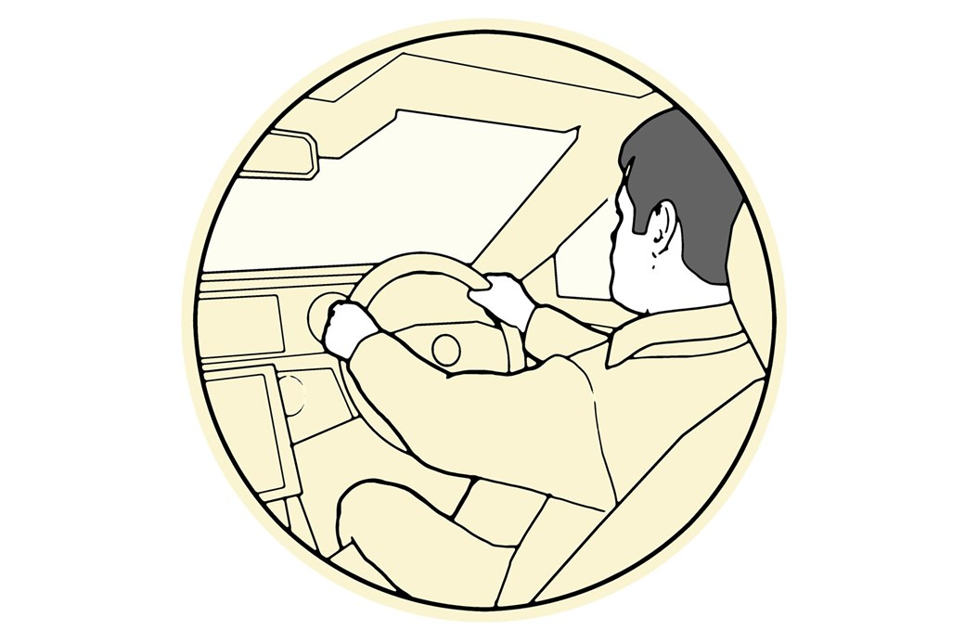

[The SAE, the Society of Automotive Engineers,](http://www.sae.org/about/) has created a lexicon of autonomy. Level 1, the most basic type, is where one element of the driving process is taken over in isolation, using data from sensors and cameras, but the driver is very much still in charge. This started in the late 1990s at Mercedes-Benz, with its pioneering radar-managed cruise control, while Honda introduced lane-keep assist on the 2008 Legend. These were the first steps towards removing the driver’s duties behind the wheel.

* **When?** The first steps in 1990s/00s
* **Includes:** Lane-keep assist, auto cruise control
* **Who’s driving?** Driver is still in control

## Level 2 driverless cars: chips control two or more elements

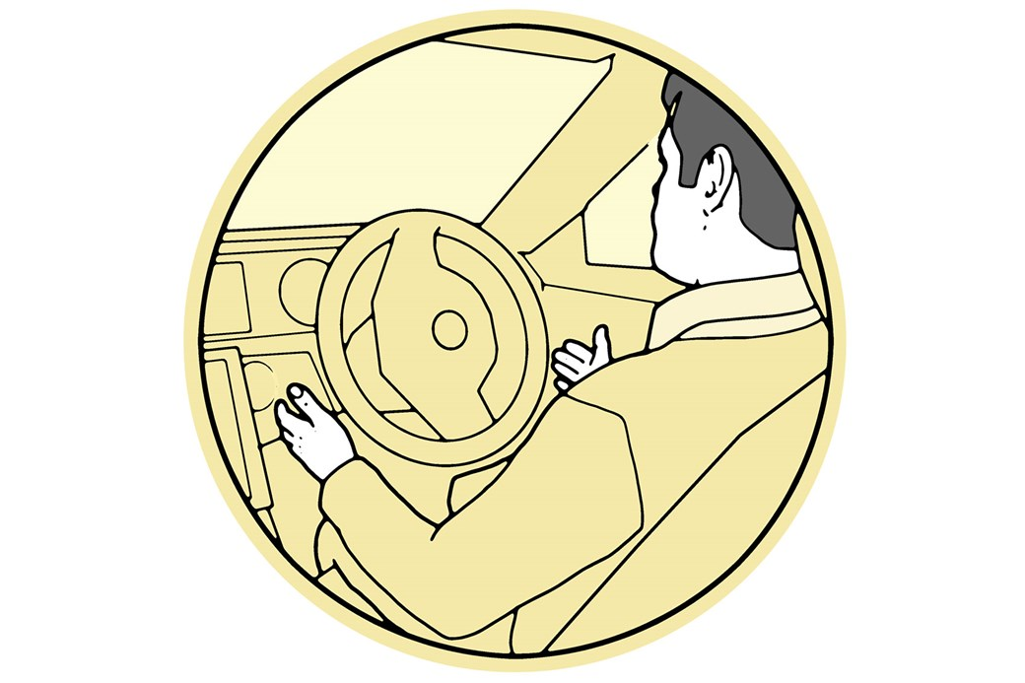

Level 2 autonomy is where we’re at today: computers take over multiple functions from the driver – and are intelligent enough to weave speed and steering systems together using multiple data sources. Mercedes says it’s been doing this for four years. The latest [Mercedes S-Class](https://www.carmagazine.co.uk/mercedes-benz/s-class/) is Level 2-point-something. It takes over directional, throttle and brake functions for one of the most advanced cruise control systems yet seen – using detailed sat-nav data to brake automatically for corners ahead, keeping a set distance from the car in front and setting off again when jams clear, with the driver idle.

* **When?** Current state of the art
* **Includes:** Lane-change mode, self-parking features etc
* **Who’s driving?** Human hands-on at all times

## Level 2+ autonomous cars: somwhere in between

Nestled in between Level 2 and Level 3, Level 2+ is more where most car makers hope to be by the end of this year. It’s a level that’s been coined by [Nvidia](https://www.nvidia.com/en-gb/self-driving-cars/drive-platform/), and although not quite the driverless Level 3 below, it’s a little more than Level 2. With Level 2+ the driver is still alert and in control, but the vehicle is also well aware of its surroundings – and make adjustments if necessary. As well as the outside, the car is more aware of the drivertoo, and will monitor things like tiredness.

* **When?** End of the year
* **Includes:** Driver monitoring, and more complex tasks
* **Who’s driving?** Still human, but the car is aware of what's going on

## Level 3 autonomous cars: the car can boss safety-critical functions

Highly automated vehicles are not far off. The SAE calls Level 3 ‘conditional automation’ – a specific – mode which lets all aspects of driving be done for you, but crucially the driver must be on hand  to respond to a request to intervene. Audi calls its [new A8](https://www.carmagazine.co.uk/audi/a8/) a Level 3 ready autonomous car – meaning the car has the potential to drive itself in certain circumstances, where it will assume control of all safety-critical functions. How? By refining maps, radar and sensors and fusing this environmental data with ever-wiser and faster processors and logic. Today’s assumption of a two-second comms lag will soon look very slow.

* **When?** The next big thing: 2020
* **Includes:** Next-gen sensors, algorithms, new laws
* **Who’s driving?** Driver still on standby, but can be hands-off for periods of time

## Level 4 driverless cars: fully autonomous in controlled areas

## 

Early next decade cars will fully drive themselves in geofenced metropolitan areas, as HD mapping, more timely data, car-to-car comms and off-site call centres (to deal with unusual hazards) improve accuracy. ‘You won’t really need the driver in Level 4,’ says Merc’s autonomous guru Christoph von Hugo. ‘The likelihood is you will just be renting the car, rather than owning it. You won’t take this car on vacation to Florida but you’ll take it on an urban journey around New York, say. It is easier to have ultra-detailed mapping for carefully defined areas.’ Twenty car makers say they’ll sell autonomous cars in the US by 2022.

* **When?** Due early to middle of next decade
* **Includes:** Driverless cars, shared pods
* **Who’s driving?** Genuine hands-off driving

## Level 5 driverless cars: fully autonomous, anywhere. Driver optional...

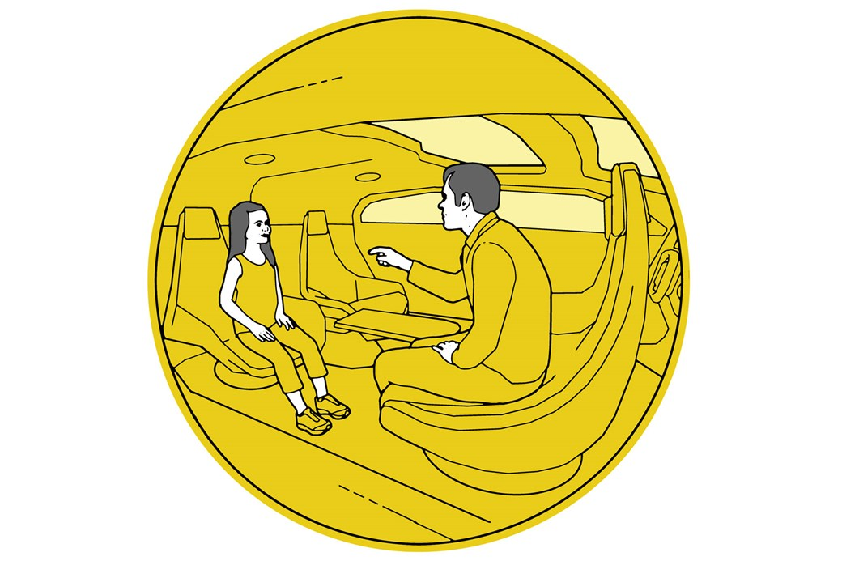

The difference between Level 4 and 5 is simple: the last step towards full automation doesn’t require the car to be in the so-called ‘operational design domain’. Rather than working in a carefully managed (usually urban) environment with lots of dedicated lane markings or infrastructure, it’ll be able to self-drive anywhere. How? Because the frequency and volume of data, and the sophistication of the computers crunching it, will mean the cars are sentient. It’s a brave new world – and one that Google’s Waymo car is gunning for, leapfrogging traditional manufacturers’ efforts. The disruption will be huge: analysts HIS forecast 21 million autonomous vehicles globally by 2035.

* **When?** Not long after Level 4, mid next decade
* **Includes:** Far-roaming robo taxis
* **Who’s driving?** Steering wheel optional